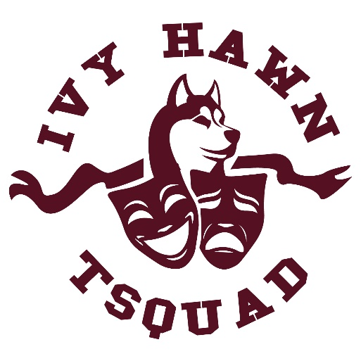
TSQUAD AUDITION FORM
Audition Forms are due to Mrs. Terhune on or before August 26, 2025!

Students Eligible: 3rd to 5th grade students
Needed for audition:
- Short memorized monologue. (30sec - 1 minute in length)
- TSquad Member list will be posted by Friday, Aug. 29th!

Student Name: _____________________________________________________________________________________
Grade & Homeroom Teacher: _________________________________________________________________________
Parent Name: _________________________________ Phone: ______________________________________________
Parent email information:_____________________________________________________________________________
Student Drama Experience (write more information on back if needed-- or attach a resume):
________________________________________________________________________________________________________________________________________________________________________________________________________________________________________________________________________________________________________________________________________________________________________________________________________
Would you like to run for an officer position this year: Yes ______ No ______.
If you marked yes, which position (President or Vice President): _______________________________________

My student has my permission to audition for the Ivy Hawn TSquad. I understand not all students who audition will be cast. If cast, my student will attend all meetings for which they are called. If my student is cast, I understand the financial obligations and performance requirements that are required (please see TSquad Fees document and What I Need to Know for Auditions document on Mrs. Terhune’s Website).

Parent Signature: _________________________________________________________Date:______________________

