Wednesday, Sept. 17

2:25 to 4:30 PM

3rd – 8th grade students

Call backs, if needed:

Friday, Sept. 19

3:15 to 4:30 pm

Auditions For:

**Robin Hood and   
His Merry Men**

By Richard Gremel

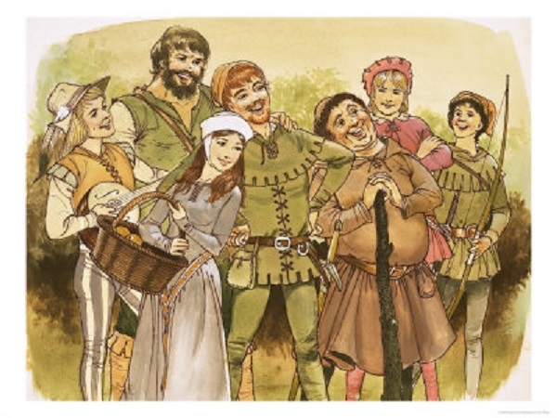



*Please return Audition form by Tue., Sept. 16

To Mrs. Stewart or Mrs. Terhune

Students Eligible: 3rd to 8th grade students

Needed for audition:

* Short memorized monologue or poem. (30 sec. to 1 min. length)
* If time allows, we will be reading from the script.
* ***Cast list will be posted by Fri., Sept. 19th in both lobbies and at both drama classrooms unless call backs are needed.***

Other Information:

* Complete ***TENTATIVE Rehearsal Schedule*** is posted on the back. Please look at schedule and **mark any and ALL dates that are conflicts.** Students must attend all rehearsals for which they are called. Each day of rehearsal will cover certain parts of the show…**Please list on back ALL Conflict dates for your student.**
* *Robin Hood and His Merry Men* will perform on **Fri., Dec 5th at 6:30pm; Saturday, Dec. 6th and Sunday, Dec. 7th at 2:30pm. We are hoping to do a streaming performance as well.** If your student cannot attend all three live performances of the play, they cannot be cast in the play.
* All Cast and Crew are required to be at all rehearsals beginning November 17th to show dates/strike.

Student Name: ________________________________________Grade & Homeroom Teacher: _____________________

Parent Name: _________________________________ Phone: _______________ Best way to Contact: ______________

Parent email information: _____________________________________________________________________________

Student Drama Experience (write information on back-- or attach a resume):

Role/s I am interested in: ___________________________________________

If I am not cast in one of those roles, I would be willing to accept another role: Yes ______ No ________.

If I am not cast in the play, I would be willing to accept a crew position: Yes ______ No ______.

I am interested in the following crew positions: ____________________________________________________________

My student has my permission to audition for ***Robin Hood and His Merry Men*.** I understand not all students who audition will be cast in the show. If cast, my student will attend all rehearsals for which they are called. If my student isn’t cast in the play, they may fulfill a crew position.

* I have listed any conflicts my student has on back. (Please include any activities that would prevent the student from attending rehearsals. It is better for the director to be informed of any routine conflicts, like dance lessons. Thank you!)

Parent Signature: _________________________________________________________Date:______________________

**TENTATIVE Rehearsal Schedule for Fall Show**

Wed, Sept. 17 2:15-4:30 pm AUDITIONS

Fri, Sept. 19 3:15-4:30 pm CALLBACKS IF NEEDED

Wed., Sept. 24 3:15-4:30 pm Read Through **(PARENT MEETING 4:30-5pm)**

Mon., Sept. 29 2:15-4:30 pm Blocking (Act 1, Sc 1 & Sc 2)

Wed. Oct. 1 3:15-4:30 pm Blocking (Act 1, Finish Sc 2)

Fri., Oct. 3 2:15-4:30 pm Blocking (Act 1, Sc 3 & Sc 4)

**Sat., Oct. 4 10:00-NOON TBD Rehearsal AND Work Day 1pm to 4pm**  
Mon., Oct. 6 3:15-4:30 pm Blocking (Act 1, Finish Sc 4 & Sc 5)

Wed., Oct. 8 2:15-4:30 pm Blocking (Act 1, Finish Sc 5)

**(MAKERS START WEDNESDAY WORK)**

Fri., Oct. 10 3:15-4:30 pm Blocking (Act 2, Sc 1 & Sc 2)

Wed., Oct. 15 3:15-4:30 pm Blocking (Act 2, Finish Sc 2)

Fri., Oct 17 2:15-4:30 pm Review (Act 1, Sc 1-3)  
Mon. Oct. 20 2:15-4:30 pm Review (Act 1, Sc 4-5)

Wed. Oct. 22 2:15-4:30 pm Review (Act 2, Sc 1-2)

Fri., Oct. 24 3:15-4:30 pm Review/Clean (Act 1, Sc 1-3)

**Sat., Oct. 25 10:00—Noon TBD Rehearsal Run Whole Play AND Work Day 1pm to 4pm**  
Mon., Oct. 27 3:15-4:30 pm Review/Clean (Act 1, Sc 4-5)

Wed., Oct. 29 2:15-4:30 pm Review/Clean (Act 2)

Mon., Nov. 3 3:15-4:30 pm Run (Act 1) **OFF BOOK**

Wed., Nov. 5 3:15-4:30 pm Run (Act 2)

**Fri., Nov. 7 3:15-4:30 pm TBA scenes as called**

Mon., Nov. 10 3:15-4:30pm Run Whole Show **COSTUME PARADE**  
Wed., Nov. 12 2:15-4:30 pm Run Whole Show

Fri., Nov. 142:15-4:30 pm Run Whole Show **(Dept Heads & Booth)**

**Sat., Nov. 15 1PM-4PM WORK DAY IF NEEDED**

Mon., Nov. 17 3:15-4:30 pm Run Whole Show **(Cue to Cue)**

Wed., Nov. 19 2:15-4:30 pm Run with TECH **+ CREW**

Fri., Nov. 21 3:15-4:30 pm Run with TECH **+ CREW**

**THANKSGIVING BREAK Nov 24-28**

Mon., Dec. 1 3:15—5:30 pm DRESS REHEARSAL **+ CREW**

Wed., Dec. 3 2:15—5:30 pm DRESS REHEARSAL **+ CREW**

**Thu., Dec 4 3:15—5:30 pm FINAL DRESS REHEARSAL EVERYONE**

**Fri., Dec. 5 Call: 5:30 pm Show: 6:30 pm**

**Sat., Dec. 6 Call: 1:30 pm Show: 2:30 pm**

**Sun., Dec. 7 Call: 1:30 pm Show: 2:30 pm, Cast Party 4-6pm**

**CAST OF CHARACTERS TO AUDITION FOR:**

**LEADS:**

Robin Hood

Maid Marian

Sheriff of Nottingham

Prince John

**SUPPORTING:**

Matilda

Kevin

Friar Tuck

Little John

Duncan

Woodsman

Guard 1

**ENSEMBLE:**

King Richard

Guard 2

Lady Gwen, Helena, Elizabeth, Jacquelyn, Isabel, Cassandra, Gertrude, Sybil

Citizen 1 & 2

Narrator

Merry Man 1-5

Mac

*Characters, not tech positions:* Stage Manager, Lighting Guy, Sweeper, Costumer 1 & 2, Prop Guy, Tech Guy, Throne Guys